Cloud Computing Overview (AWS CLI)

HOS02: Installing the AWS CLI

Developed by Marvin Gold 12/17/2020  
Reviewed by Kim Nguyen Class of 2021

School of Technology and Computing

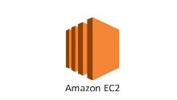

**Justification**

**Learning Outcomes**

* Install and set up the AWS CLI on Windows
* Install and set up the AWS CLI on Mac
* Install and set up the AWS CLI on Linux

**Background**

For this class we are going to use the Amazon EC2 instance that we created in Hands on Skills (HOS01). Since we are using an Amazon Linux 2 AMI the AWS CLI is already installed. This practice will walk you through setting it up on a Mac, Windows PC, or Linux computer.

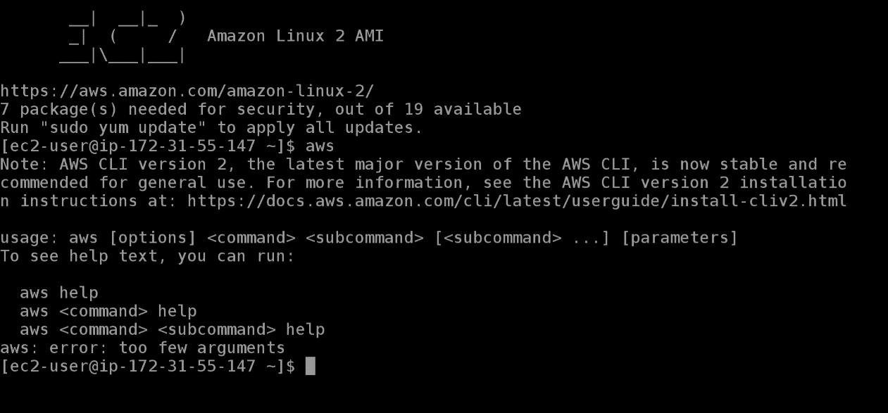

Even though we are going to primarily use our Amazon EC2 instances, for this practice please install the AWS CLI on the operating system of your choice.

**Resources**

[**Install the AWS CLI on Linux**](https://docs.aws.amazon.com/cli/latest/userguide/install-cliv2-linux.html)

[**Install the AWS CLI on Mac**](https://docs.aws.amazon.com/cli/latest/userguide/install-cliv2-mac.html)

[**Install the AWS CLI on Windows**](https://docs.aws.amazon.com/cli/latest/userguide/install-cliv2-windows.html)

**Completion Criteria**

AWS CLI 2.0 Successfully installed onanother operating system.

**Step 1: Upgrade your AWSCLI on your Amazon Linux 2 EC2 Instance**

**Install AWSCLI Version 2**

[**https://docs.aws.amazon.com/cli/latest/userguide/install-cliv2-linux.html**](https://docs.aws.amazon.com/cli/latest/userguide/install-cliv2-linux.html)

**Then add**

**alias aws=’usr/local/bin/aws’ to your .bashrc**

**Source ./bashrc**

**Then aws –version**

**You should have awscli version 2.1**

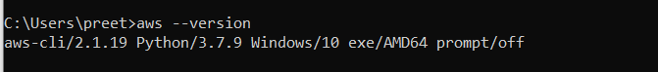

**Step 2: Pick your Operating System**

Pick whichever operating system from above that you want to install the AWS CLI on, then follow the instructions linked.

